Tên: Trần Nguyễn Quốc Cường

Lớp: SE1709

**Bài tập SQL**

1.

**Code:**

CREATE TABLE WORKER (

WORKER_ID INT NOT NULL PRIMARY KEY,

FIRST_NAME CHAR(25),

LAST_NAME CHAR(25),

SALARY INT(15),

JOINING_DATE DATETIME,

DEPARTMENT CHAR(25)

);

insert into WORKER

(WORKER_ID, FIRST_NAME, LAST_NAME, SALARY, JOINING_DATE, DEPARTMENT) values

(001, 'Monika', 'Arora', 100000, '2014-02-20 09:00:00', 'HR'),

(002, 'Niharika', 'Verma', 80000, '2014-06-11 09:00:00', 'Admin'),

(003, 'Vishal', 'Singhal', 300000, '2014-02-20 09:00:00', 'HR'),

(004, 'Amitabh', 'Singh', 500000, '2014-02-20 09:00:00', 'Admin'),

(005, 'Vivek', 'Bhati', 500000, '2014-06-11 09:00:00', 'Admin'),

(006, 'Vipul', 'Diwan', 200000, '2014-06-11 09:00:00', 'Account'),

(007, 'Satish', 'Kumar', 75000, '2014-01-20 09:00:00', 'Account'),

(008, 'Geetika', 'Chauhan', 90000, '2014-04-11 09:00:00', 'Admin');

CREATE TABLE TITLE (

WORKER_REF_ID INT,

WORKER_TITLE CHAR(25),

AFFECTED_FROM DATETIME,

FOREIGN KEY (WORKER_REF_ID) REFERENCES Worker(WORKER_ID)

ON DELETE CASCADE

);

insert into TITLE

(WORKER_REF_ID, WORKER_TITLE, AFFECTED_FROM) values

(1, 'Manager', '2016-02-20 00:00:00'),

(2, 'Executive', '2016-06-11 00:00:00'),

(8, 'Executive', '2016-06-11 00:00:00'),

(5, 'Manager', '2016-06-11 00:00:00'),

(4, 'Asst. Manager', '2016-06-11 00:00:00'),

(7, 'Executive', '2016-06-11 00:00:00'),

(6, 'Lead', '2016-06-11 00:00:00'),

(3, 'Lead', '2016-06-11 00:00:00');

CREATE TABLE BONUS (

WORKER_REF_ID INT,

BONUS_DATE DATETIME,

BONUS_AMOUNT INT(10),

FOREIGN KEY (WORKER_REF_ID) REFERENCES Worker(WORKER_ID)

ON DELETE CASCADE

);

insert into BONUS

(WORKER_REF_ID, BONUS_DATE, BONUS_AMOUNT) values

(001, '2016-02-20 00:00:00', 5000),

(002, '2016-06-11 00:00:00', 3000),

(003, '2016-02-20 00:00:00', 4000),

(001, '2016-02-20 00:00:00', 4500),

(002, '2016-06-11 00:00:00', 3500);

**Kết quả:**

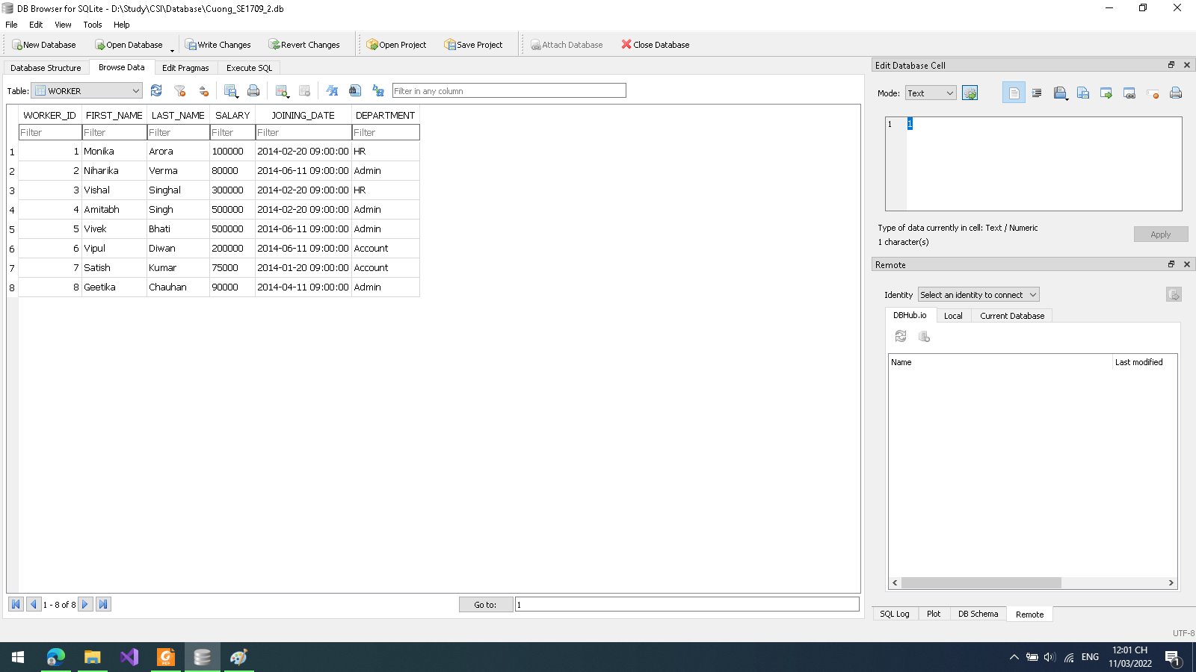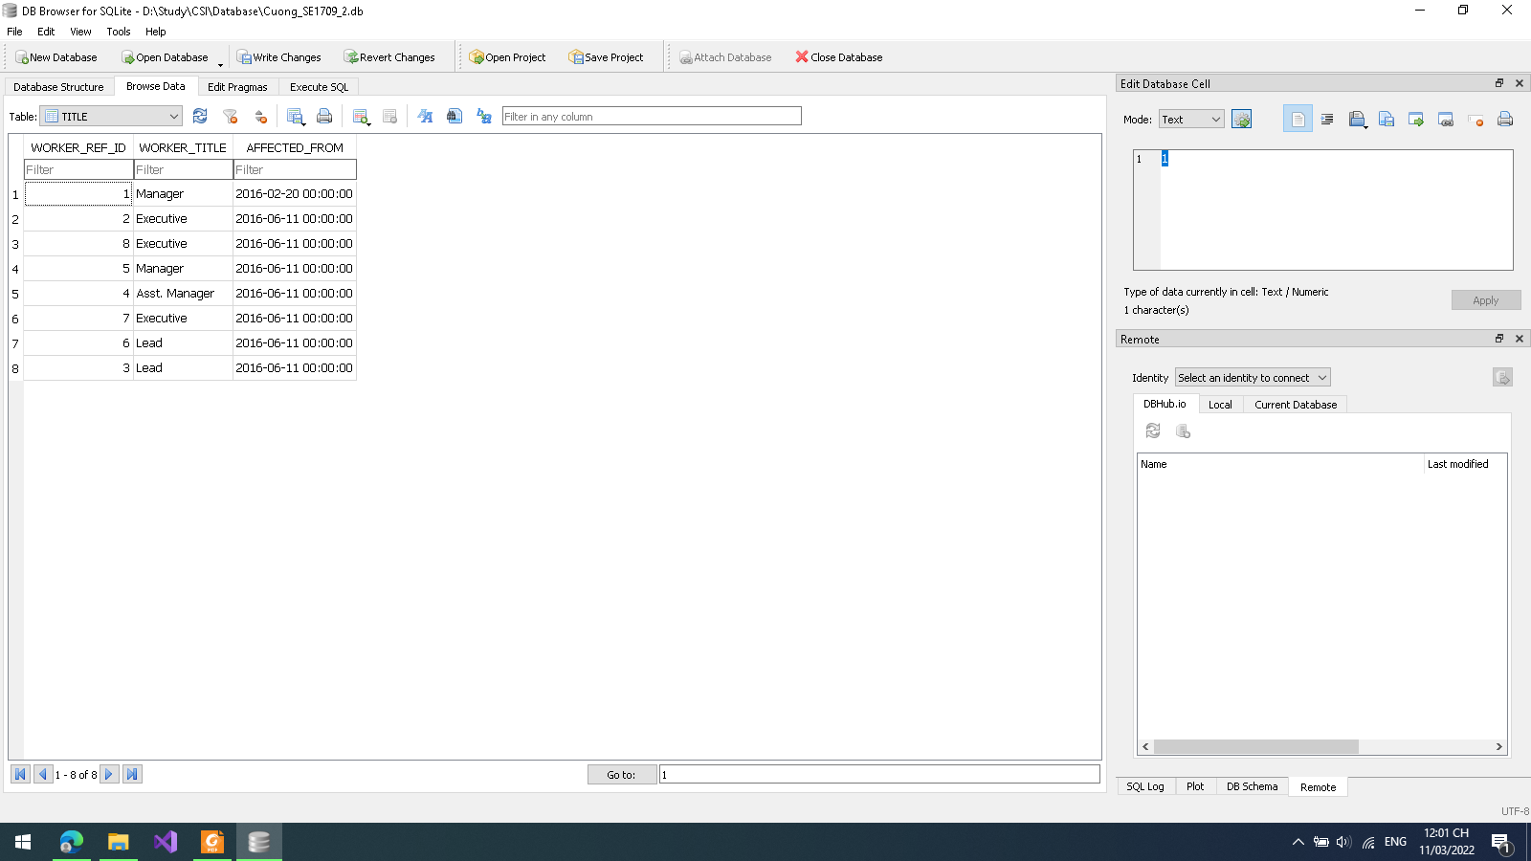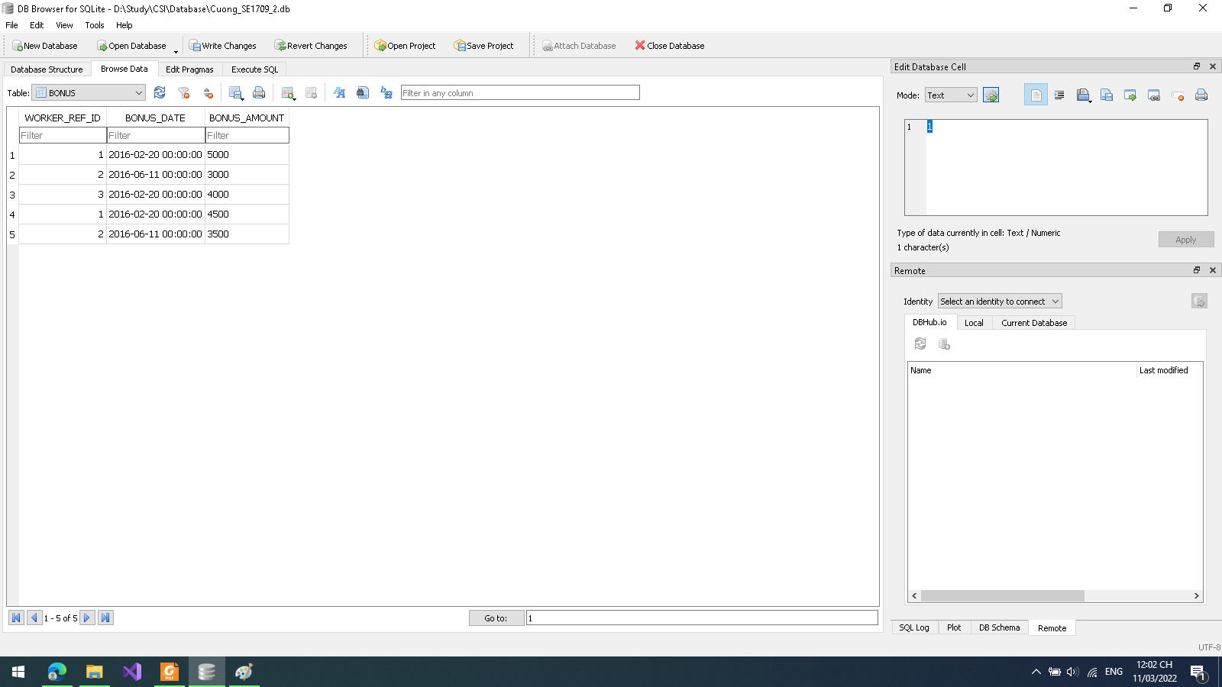

**2.**

**Code:**

select FIRST_NAME as WORKER_NAME from WORKER;

**Kết quả:**

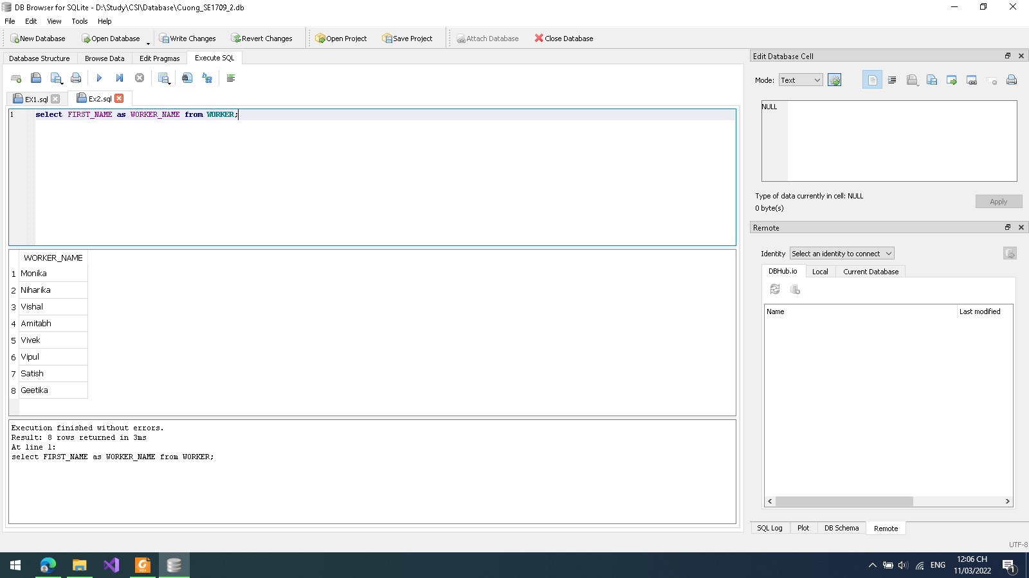

**3.**

**Code:**

select upper(FIRST_NAME) from WORKER;

**Kết quả:**

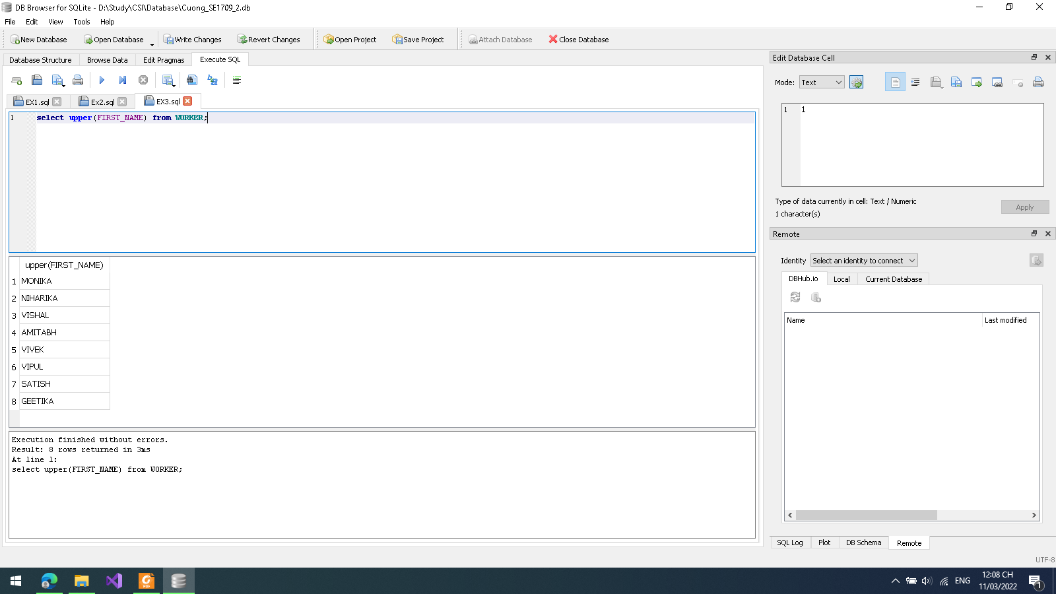

**4.**

**Code:**

select distinct DEPARTMENT from WORKER;

**Kết quả:**

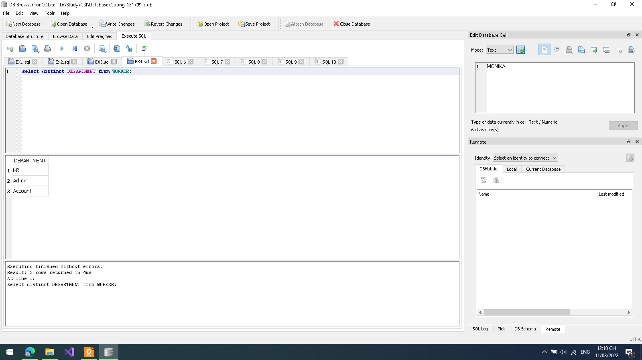

**5.**

**Code:**

select substr(FIRST_NAME,1,3) from WORKER;

**Kết quả:**

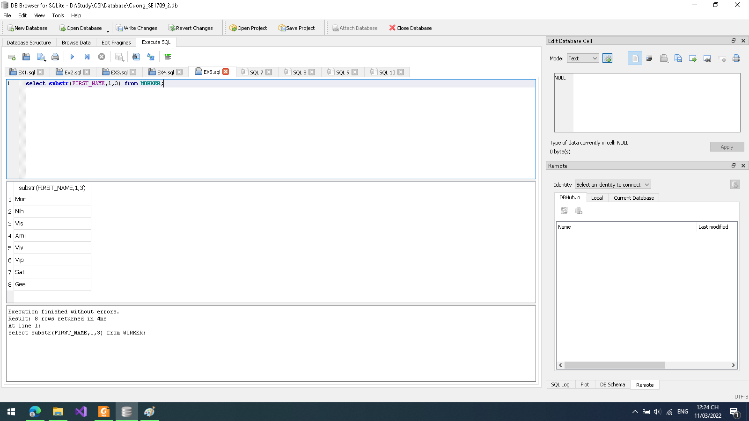

**6.**

**Code:**

select * from WORKER order by FIRST_NAME asc;

**Kết quả:**

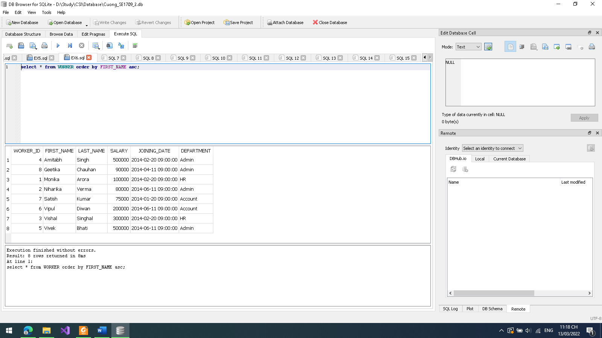

**7.**

**Code:**

select * from WORKER where FIRST_NAME in ('Vipul','Satish');

**Kết quả:**

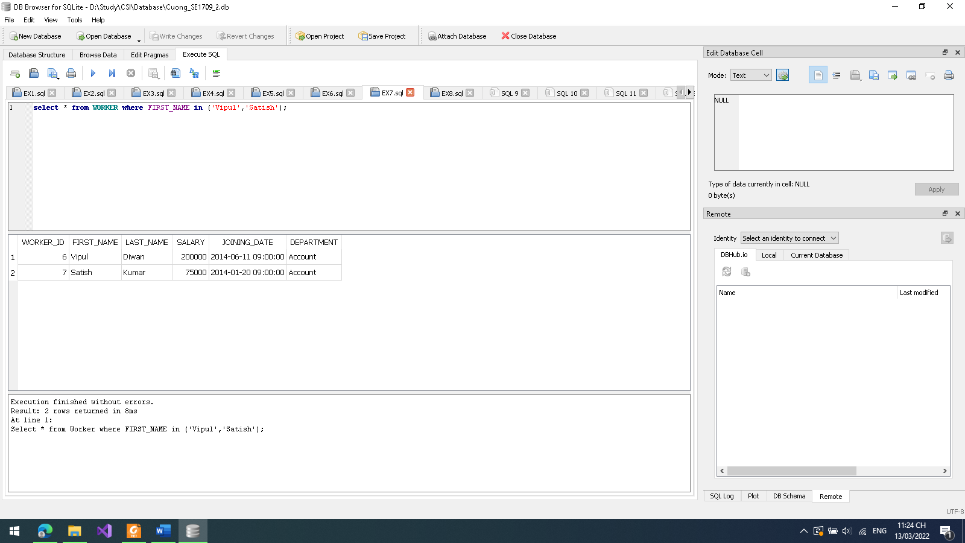

**8.**

**Code:**

select * from WORKER where FIRST_NAME like '%a';

**Kết quả:**

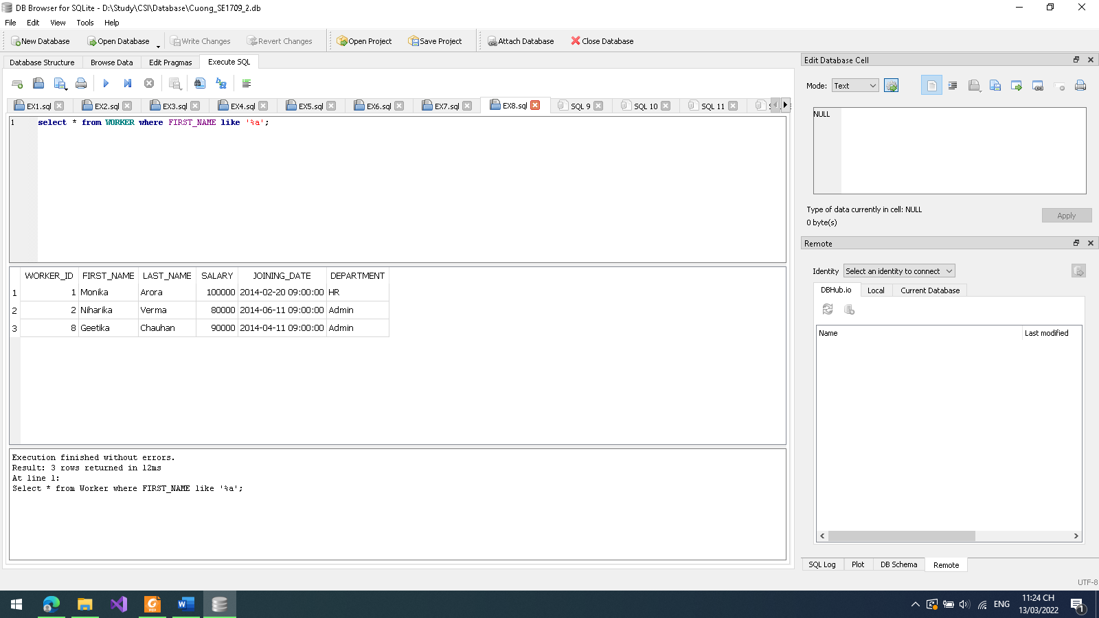

**9.**

**Code:**

select * from WORKER where SALARY between 100000 and 500000;

**Kết quả:**

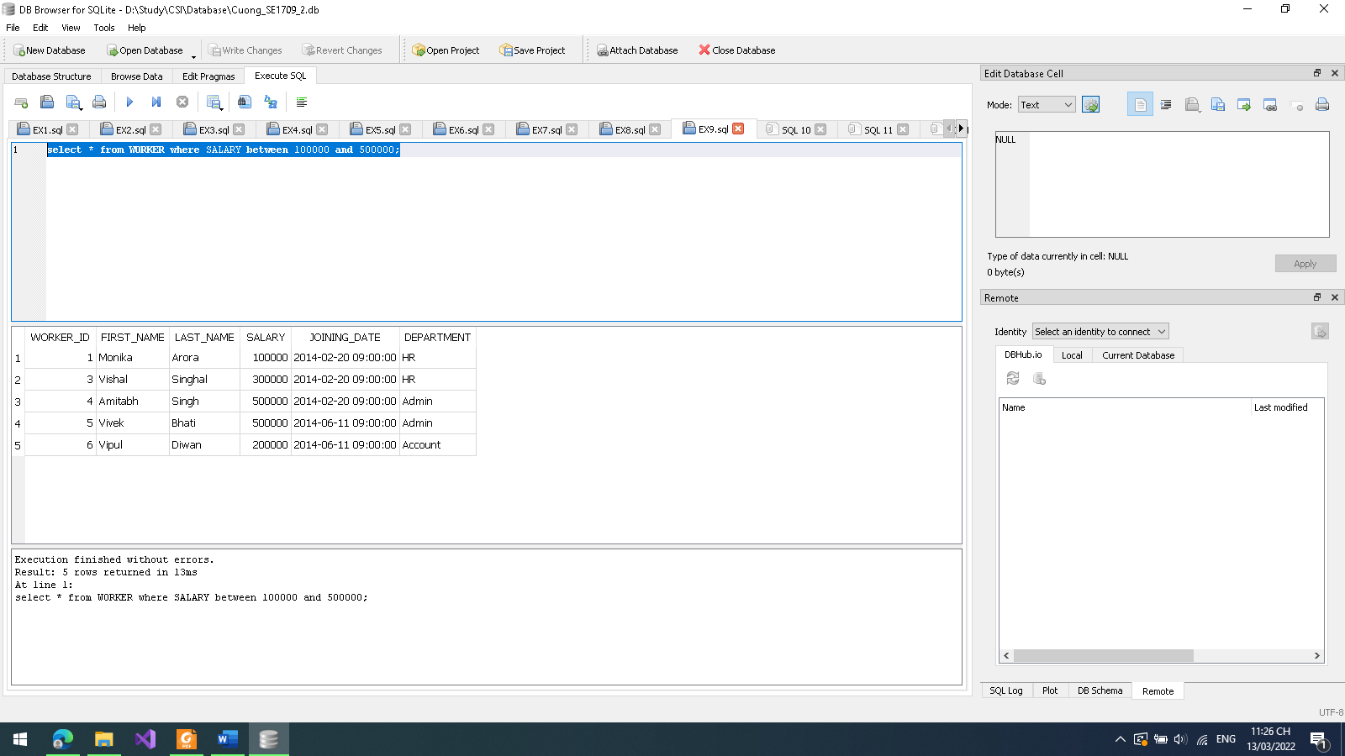

**10.**

**Code:**

select * from WORKER WHERE DEPARTMENT = 'Admin';

**Kết quả:**

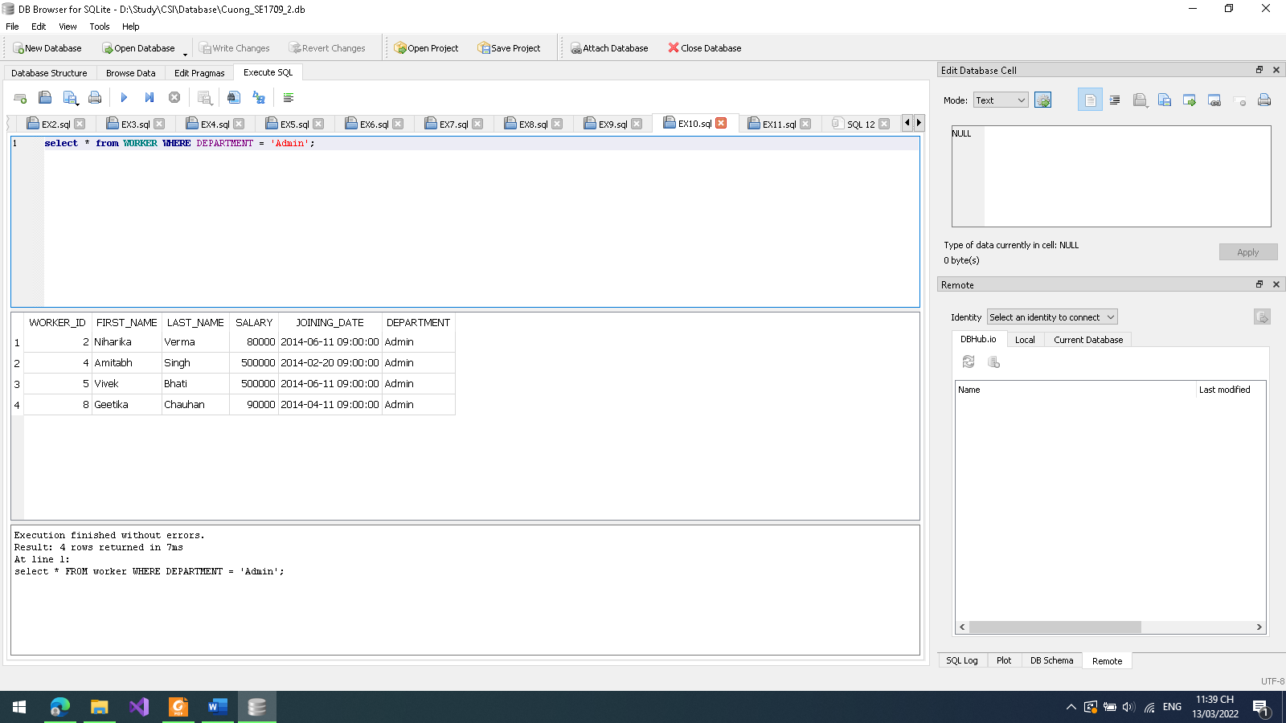

**11.**

**Code:**

select * from WORKER

INTERSECT

select * from WORKER;

**Kết quả:**

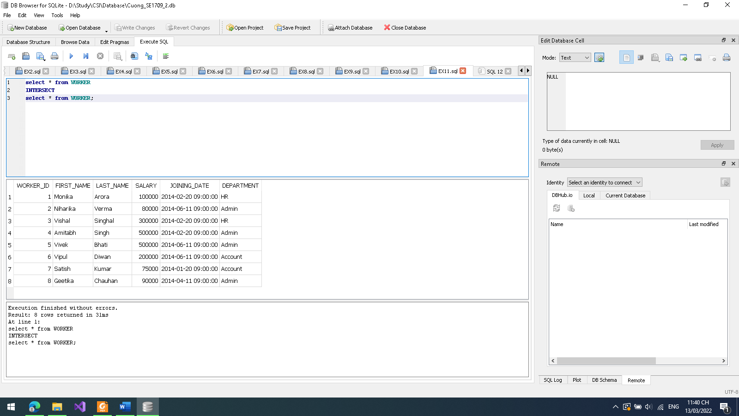

**13.**

**Code:**

**select * from Worker ORDER BY Salary DESC LIMIT 10;**

**Kết quả:**

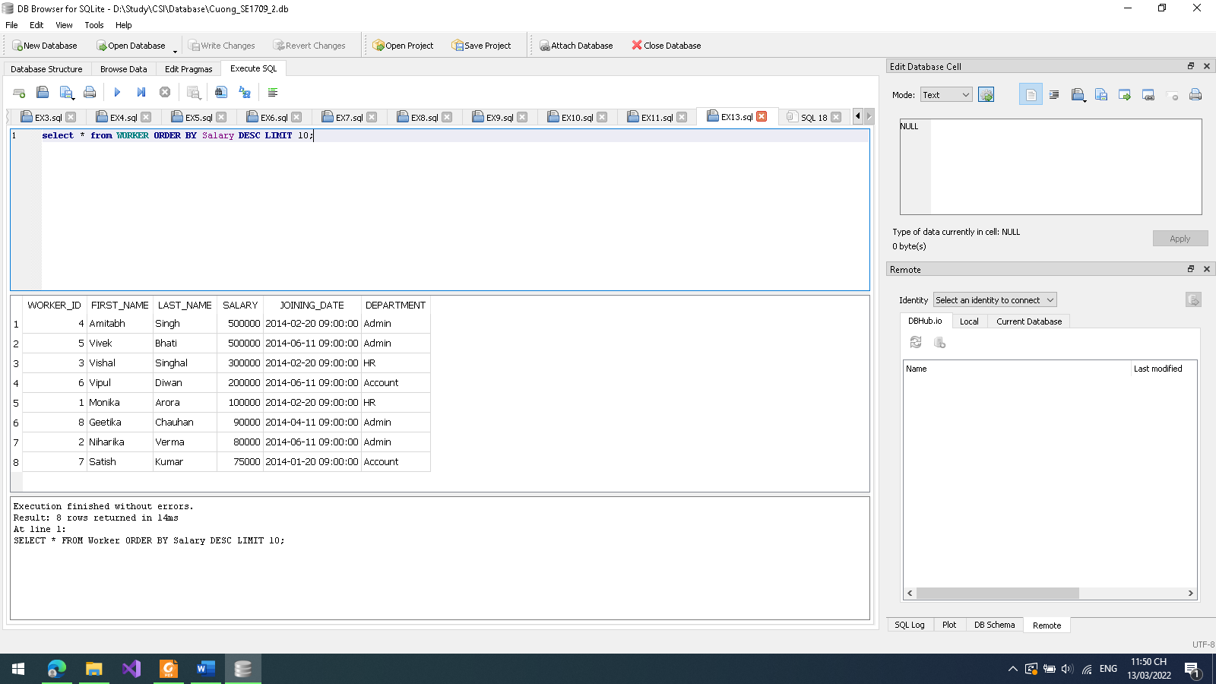

**15.**

**Code:**

select WORKER_ID, FIRST_NAME, LAST_NAME, SALARY from Worker WHERE SALARY=(select max(SALARY) from Worker);

**Kết quả:**

